1. Can you tell me a little bit about your background and what prompted you to get involved in this project?

* Growing up in Ithaca with parents who work at Cornell, I was immersed in the Cornell atmosphere at an early age. In 9th grade, I heard about the Elephant Listening project and as someone who loves animals and nature I decided to volunteer with the group in the summer of 2013. As a volunteer, I was involved with going through the recorded audio data and hand selecting the elephant calls. Moving forward, I always had in the back of my mind the idea that the work I had been doing surely could be automated and knew how powerful such a tool could be. Near the end of high school and when I went to Stanford, I became fascinated with computer science and the field of AI. As I learn more about the field of computer science, my passion for the natural sciences, conservation, and sustainability has motivated me to look for exciting, meaningful projects that bridge the gap between my two passions. In following this pathway, last year when I was taking an upper level AI/Deep Learning class and was looking for a final project topic, my team mate Nikita Demir and I decided that working on a project related to my volunteering work with the Elephant Project would be an incredible opportunity. Not only was the project of developing an automated elephant call detector interesting from a computational perspective, but it also served an amazing real world cause. From that moment, we went on to receive an award for one of the top class projects out of around 200 other projects and have continued now under the mentorship of Andreas Paepcke to work towards developing an improved and practically useful algorithm to help in the study and protection of elephants.

1. When and where did the Cornell Lab of Ornithology collect the data that you were using?

* The Elephant Listening project was established in 2000 and has since been collecting audio recordings across different sites in the central African forests. They have recorded sounds from over 150 different locations and have on the order of a million hours of recordings. The data that we are using for our model is only a subset of all of the data that they have collected and comes from the Nouabalé-Ndoki National Park of the Republic of the Congo in Africa. Unlike much of the past collected data which came from forest clearings, named bais, where Elephants are known to congregate, the data that we are working on focuses on a new effort to detect elephants deep within the forest itself. In total we have around 3600 hrs hours of recorded data from over 40 different recording device locations scattered throughout the Nouabale forest taken from January 2018 through July 2018. These recording devices are placed deep within the forest, often requiring a day or multiple days of hiking to be reached. Audio data presents an ideal means for tracking and documenting elephants in these dense, vast natural habitats, as the sounds of elephant calls can travel and be captured nearly a kilometer away (in comparison to visual systems which are incredibly distance limited in dense forest settings). In regards to some of the papers that you saw from the Elephant Listening group, one challenge of the new forest data is that the elephant calls are often fainter, harder to detect, and more easily confused with a collection of other sounds deep within the forest compared to in the more idyllic setting of bai clearings.

1. Have you traveled to the study sites where the data were collected? If so, can you describe what that was like?

* Unfortunately, Nikita and I have not had the opportunity to travel to the physical data collection sites in Africa. This would be an amazing opportunity in the future if we get the chance! Right now we are working primarily on post processing of data that has been extracted from the field, but one ultimate goal is to eventually help design or influence the creation of real time detectors that can be deployed in the field and transmit real time data to assist in elephant conservation.

1. When your model detects an elephant call in a sample, what does it “tell” you (i.e. how exactly do end users interact with the model)?

* The current model that we are developing aims to function as much like a human volunteer as possible. Namely, just as a volunteer goes through hours of audio data and for each identified elephant call marks a start and end time, our deep learning based AI algorithm looks to do the same. Therefore, given an audio recording of any length (usually 24hr segments), our algorithm processes this audio file and generates a spreadsheet of predicted start and end times for all of the elephant calls that it detects. Therefore, researchers in the elephant listening project will be able to go to those locations in the audio file to confirm or deny the prediction and also be able to use prediction numbers to help make population models, etc. The goal is to dramatically decrease the time needed to process the ever growing pool of data that researchers collect. AI methods provide tremendous opportunity to do so.

1. How did you go about validating your model and determining the false positive rate?

* In working with the Elephant listening project, we have created a large training and a separate test set of audio recording files. Therefore, we are able to train on a large collection of audio data and then test our models on unseen testing data to determine metrics like precision, recall, and false positive rates.

1. If this model were to be used for tracking elephant vocalizations on a broader geographic scale, would autonomous acoustic recording units need to be placed at a large number of recording sites? Are there any plans for CLO or other groups to deploy a larger monitoring system like this?

* Yes, the range of the recording devices is approximately 1km I believe. So to cover more area more devices would inevitably need to be put out. However, planning can be done to maximize the coverage and tracking area while minimizing the number of recording devices used. I am not aware of any groups looking to deploy very large monitoring systems and unfortunately have not heard of the CLO. However, as algorithms and tools for audio data understanding continue to develop, I believe that acoustic data will become more and more prevalent in conservation research. In particular, audio data can address many challenges faced with image based data, such as limited range, object occlusion (i.e., trees or bushes blocking animals of interest), issues with changed lighting, and data collection at night. Audio data can often capture sounds on a much larger scale and for many animals represents an essential component of communication and identification.

1. What was one thing that surprised you while you were developing this automation system?

* The many challenges that we would face. From a computer science perspective, the task of identifying elephant calls does not necessarily seem super difficult. Specifically, elephant calls themselves are fairly standard in shape and do not have a whole lot of variation. However, what we learned is that it is almost not the elephant calls themselves that are the hardest to detect, but rather it is the incredible amount of low-level background noise and variation in the data that our models must encode not to mistake for elephant calls. We have learned that in the forest a whole lot goes on and because elephant calls are fairly rare on a day to day time scale, it is challenging to make a model that is sensitive to both detecting elephant calls when they happen but also avoids false positives from sounds that can easily confuse the model.

1. What is the main message you’d want your audience to leave with?
2. Computer science and AI in particular has great potential to benefit the field of ecology and conservation. As data sources become prolific and the amount of data quickly grows beyond the capacity of current hand analysis, the time is ripe to develop an active interdisciplinary dialog. Both sides cannot do it alone, the efforts of computer scientists are frivolous and unguided without the domain expertise of scientists, while at the same time, scientists are more and more left unable to handle and explore amazing unanswered questions without the aid of complex data analytics.
3. The devil of machine learning lies in the reality of real-world data sets. None of the data are curated ahead of time towards purity and pedagogy for school courses. A myriad more hyper parameters from the domain and preprocessing must be considered than the ones known to be associated with standard models

Some photos that may be of use:

Here is a photo where the blue dots represent the recording sites:

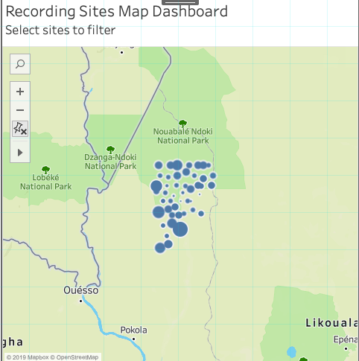

Elephants in a Bai clearing

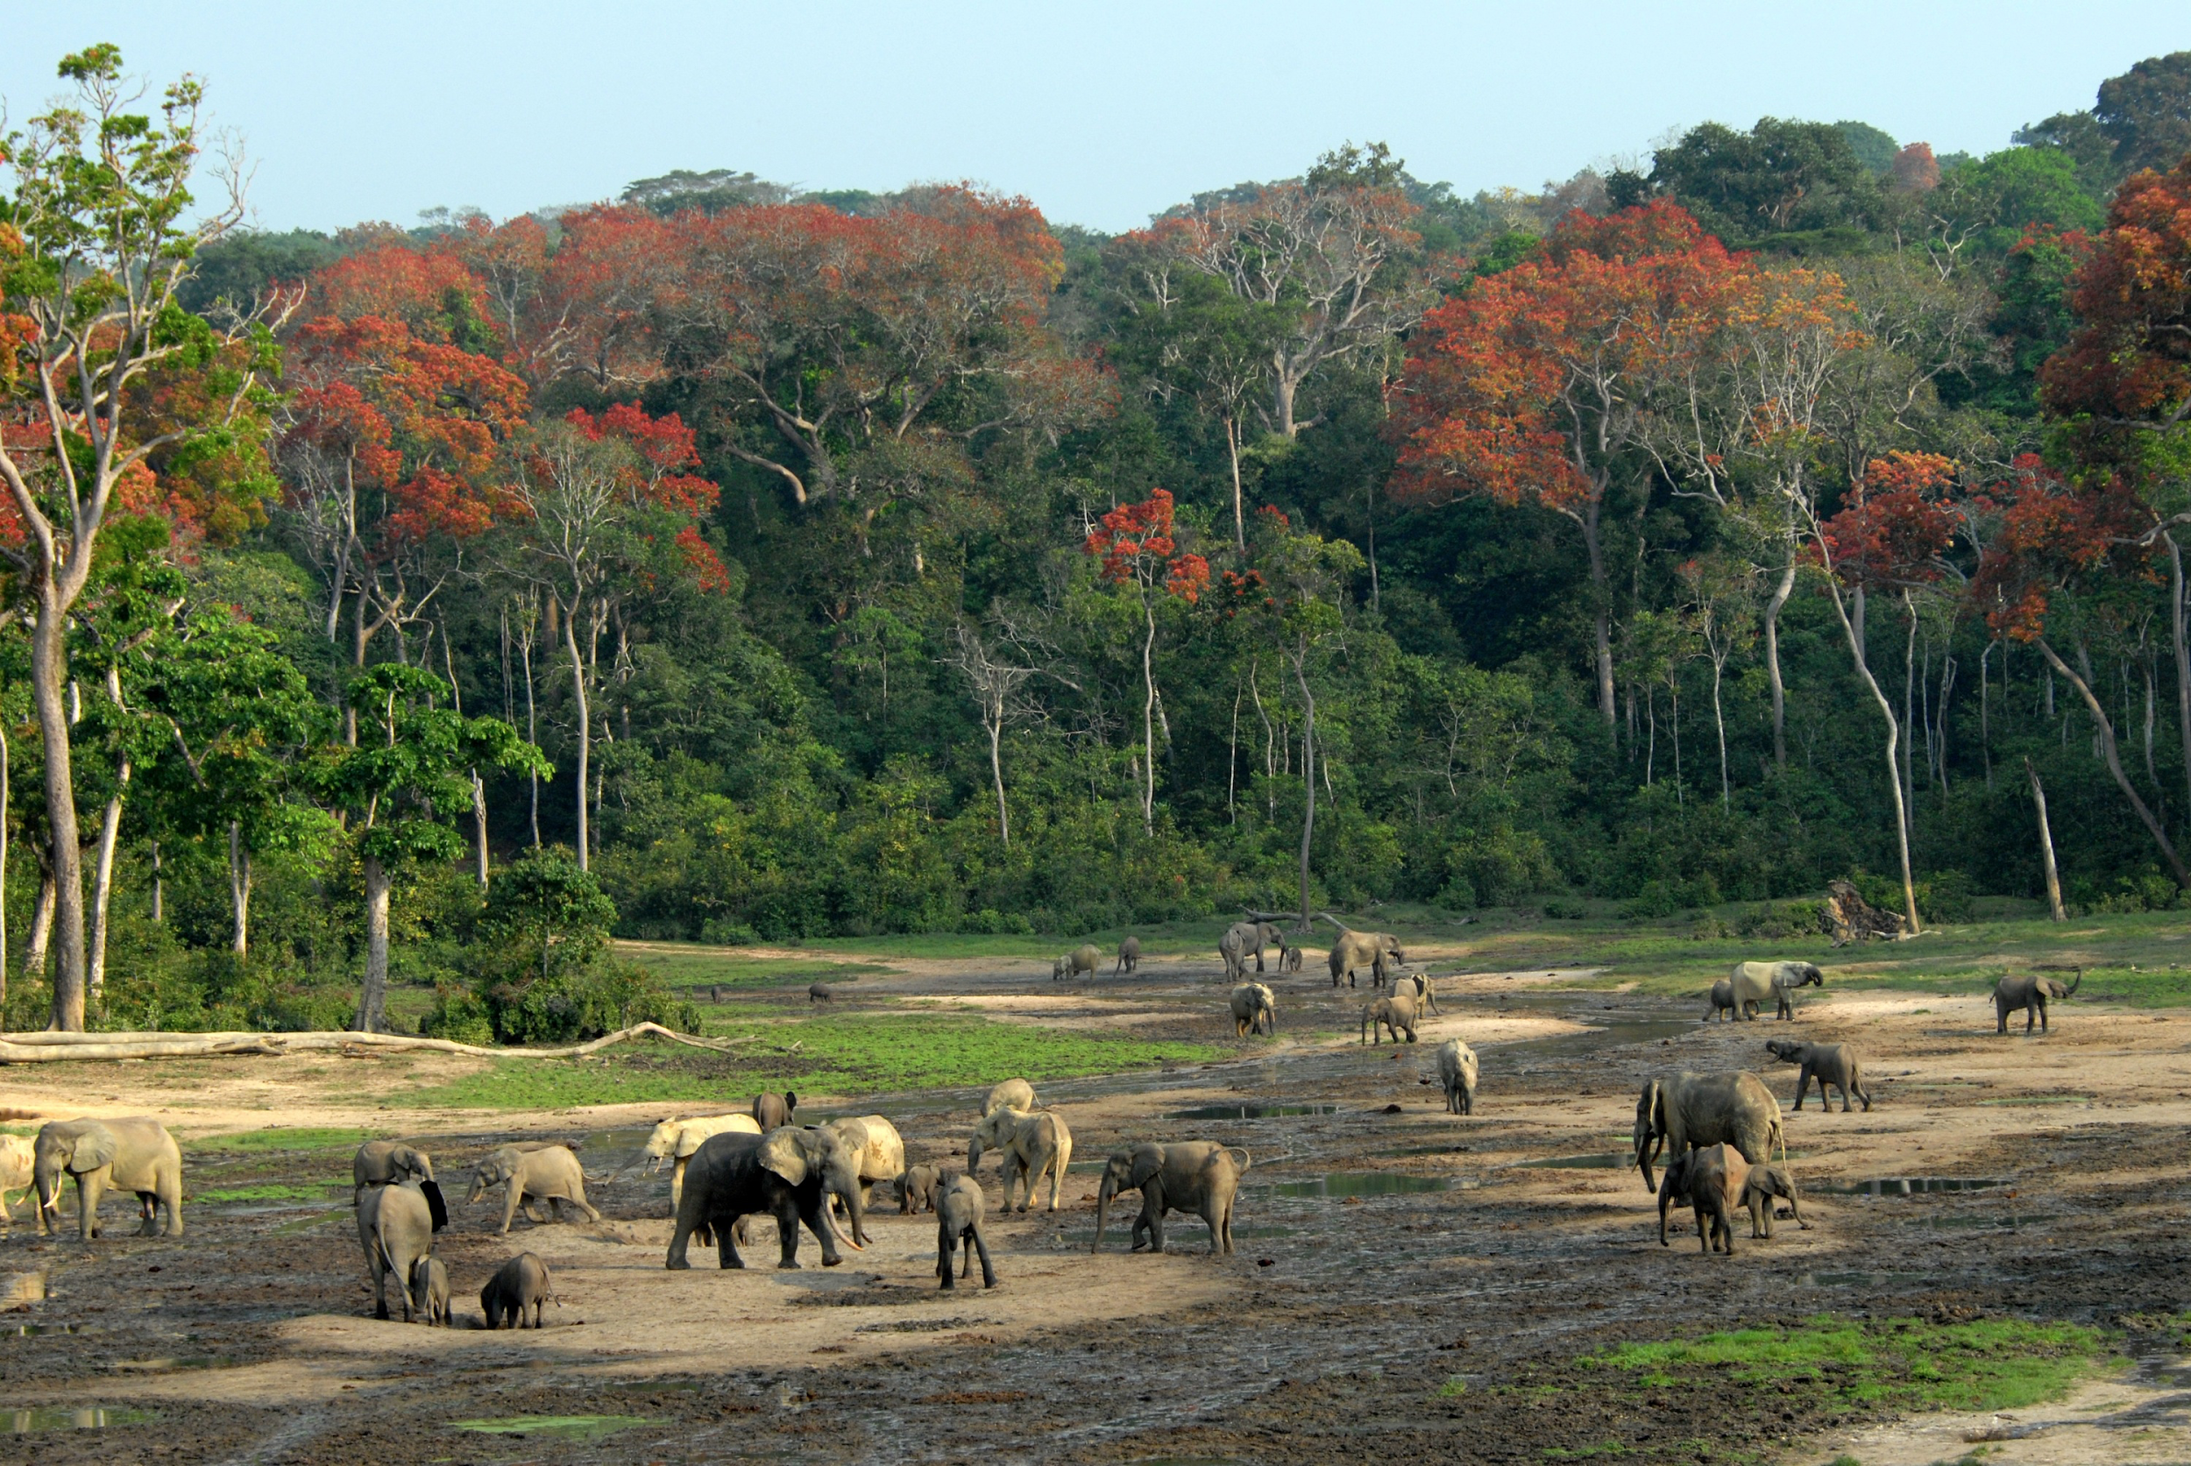

Elephant Calls In a Spectrogram

